Data Quality and Validation in ETL

Question 1: Define Data Quality in the context of ETL pipelines. Why is it more than just data cleaning?
Solution:
Data Quality in ETL refers to the accuracy, completeness, consistency, reliability, and validity of data flowing through extraction, transformation, and loading processes. It is more than just data cleaning because it also involves enforcing business rules, validating data formats, ensuring referential integrity, removing duplicates, and maintaining consistency during transformation and loading.

Question 2: Explain why poor data quality leads to misleading dashboards and incorrect decisions.
Solution:
Poor data quality results in incomplete, inaccurate, or inconsistent information, which causes KPIs, reports, and dashboards to display wrong insights. This leads to incorrect business decisions, such as wrong forecasting, misallocation of resources, or reporting errors.

Question 3: What is duplicate data? Explain three causes in ETL pipelines.
Solution:
Duplicate data refers to repeated records that represent the same business entity.
Causes:
1. Same file loaded multiple times.
2. Missing or weak primary keys.
3. Incorrect merge, join, or transformation logic.

Question 4: Differentiate between exact, partial, and fuzzy duplicates.
Solution:
Exact duplicates: All fields are exactly the same.
Partial duplicates: Some fields match but others differ.
Fuzzy duplicates: Values are nearly similar but not identical.

Question 5: Why should data validation be performed during transformation rather than after loading?
Solution:
Because once data is loaded into the warehouse, incorrect or inconsistent data may corrupt final tables, dashboards, or aggregates. Validating during transformation ensures only correct and clean data enters the final system, reducing reprocessing and improving accuracy.

Question 6: Explain how business rules help in validating data accuracy. Give an example.
Solution:
Business rules ensure that data meets required business logic and constraints. They help verify accuracy, consistency, and correctness.
Example: Quantity must be greater than 0. If Quantity = 0 or NULL, validation fails.
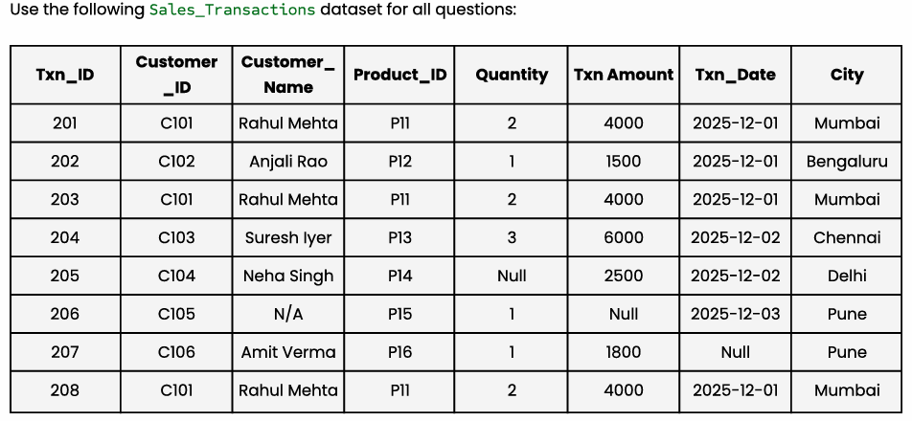
Question 7: Write an SQL query to list all duplicate keys and their counts using the business key (Customer_ID + Product_ID + Txn_Date + Txn_Amount).
Solution:
SELECT Customer_ID, Product_ID, Txn_Date, Txn_Amount,
COUNT(*) AS Duplicate_Count
FROM Sales_Transactions
GROUP BY Customer_ID, Product_ID, Txn_Date, Txn_Amount
HAVING COUNT(*) > 1;

Question 8: Enforcing Referential Integrity
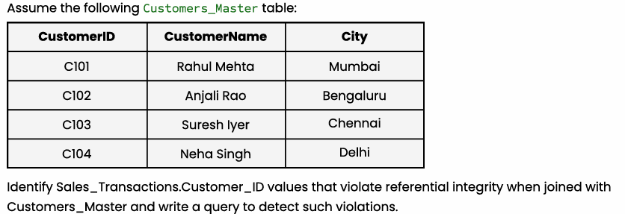
Solution:
Customer_ID values such as C105 and C106 do not exist in the Customers_Master table.

SQL Query:
SELECT st.Customer_ID
FROM Sales_Transactions st
LEFT JOIN Customers_Master cm
ON st.Customer_ID = cm.CustomerID
WHERE cm.CustomerID IS NULL;

